**Magnetic Field Mapping**

**Pre-lab questions**

1. What is the goal of this experiment? What physics and general science concepts does this activity demonstrate to the student?
2. What is one similarity between magnetic field and electric field?
3. What is one difference between magnetic field and electric field?
4. Why can’t magnetic field lines cross each other? What would be true about the magnetic field at the point of crossing if they did?

The goal of this experiment is to help understand the magnetic field by using small compasses to visualize and trace magnetic field lines for a dipole, a repulsive dipole, and a quadrupole field.

**Introduction**

The magnetic field differs from the electric field (arising from electric charges) in that, as far as has been observed so far, the basic unit of magnetic “charge” is a dipole – a pair of equal (strength) and opposite (polarity) magnetic poles as occurs in a bar magnet. But since the magnetic force between magnetic poles follows the same form as Coulomb’s law for electric charges, it is not surprising that the magnetic field does have notable similarities to the electric field. Magnetic field lines are an aid used to help visualize the vector magnetic field. There are some guidelines used for drawing these lines: (a) magnetic field lines begin on a north pole and end at a south pole, with that directionality, (b) the magnetic field strength is directly proportional to the density of magnetic field lines (number of field lines passing through a unit volume of space), (c) the local magnetic field vector is tangent to the field line at any point, (d) magnetic field lines do not cross, and (e) the array of magnetic field lines should have the same symmetry as the magnet configuration that produced it.

**Equipment**

Set of small, plotting compasses, 2 Alnico bar magnets.

|  |  |  |
| --- | --- | --- |
| 1 | Plotting Compasses (Set of 20) | EM-8680 |
| 1 | Bar Magnet Alnico (Set of 2) | EM-8620 |
|  | Required but not included: |  |
|  | Paper & Pencil |  |
| 1 | PASCO Capstone |  |

**Theory**

Continuing from the introduction above, here are some rules for drawing the magnetic field lines.

1. The lines begin on a north pole and terminate on a south pole. *This is actually only true for the field external to the magnet. Inside the magnet, the lines complete full loops and point from south to north. See Figure 1.*
2. The magnetic field strength is directly proportional to the density of the field lines. *This is really only true in three dimensions, but in 2-D drawings it is still true that the field is stronger where the lines are closer together.*
3. The magnetic field vector (**B**) is tangent to the field line at any point and points in the directionality of the field line from north pole toward south pole.
4. The magnetic field should have the same symmetry as the magnet configuration that produced it, e.g. a set of magnets with poles arranged along a straight line should have a magnetic field of cylindrical symmetry.
5. The lines (of the total field) cannot cross (although since the compasses used to trace the lines are not infinitely small, places where the field is sharply curved can be hard to follow and lines may seem to cross.)
6. The lines cannot stop or start in space. There is one seeming exception here. On a symmetry axis there may be a place where the field is zero. Most lines must avoid such a place, but a line on the symmetry axis must stay on the symmetry axis. On either side of the zero, the field must either point toward the zero or away from it. Thus it appears as if two lines have either started or stopped at the zero. However, there are at most only a few symmetry axes, but an infinite number of field lines (we don’t draw them all). This means the fraction of badly behaved lines is (small #)/infinity = 0, so we may ignore the poorly behaved lines. Trouble is that people tend to pick the symmetry axes and see the poorly behaved lines.

A compass needle (small magnet) will align with the (average) **B** field at the region where the needle is, as shown in Figure 1. Thus, we can use a small compass to trace the lines. Why wouldn’t a larger compass work as well?

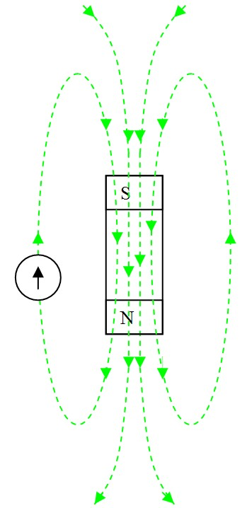 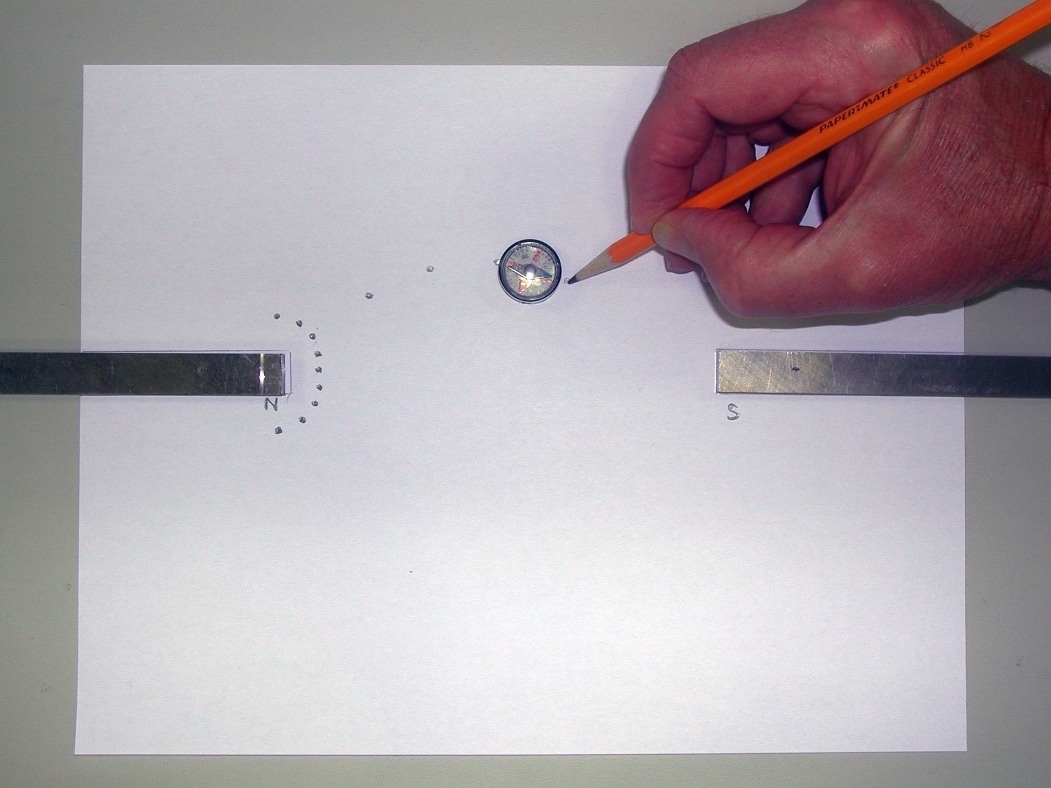

Figure 1: Dipole Field with Compass Figure 2: Attractive Dipole Setup

**Setup and Procedure**

*Note 1: the PASCO EM-8620 Alnico magnet has a groove near the North end.*

*Note 2: if the laboratory tables have metal parts, they can become magnetized and add to the total magnetic fields you are mapping. You can check you table top with a compass to see if it is affected in the region where you intend to do your field plotting. If it is, find a spot that isn’t.*

Attractive Dipole

1. Position the magnets so they are about halfway onto a piece of 8½ x 11 inch paper as shown in Figure 2. The north pole of one magnet should face the south pole of the other. Draw a line around each magnet and label the poles. Near the north end, make a semi-circle of nine dots with one dot on the symmetry axis and four above the axis and four below as shown.
2. Position the compass so the south end of the compass points to one of the dots in the semi-circle (in Figure 2, I started at the third dot from the top). Using a wooden pencil (why?) make a dot on the paper where the north end of the compass needle points. Then move the compass so the south end points to the dot you just made and mark a new mark where the north end points. Continue until you go off the paper or reach the south pole of the other magnet. Fit a smooth curve to the dots. Don’t forget that the field is a vector. Mark the directionality of the field line!
3. Now do the other eight points. Note: This should not require a lot of time. This is a quick and qualitative exercise. We are not working to three significant figures.

Repulsive Dipole

1. Set up as before with the two north ends facing. Draw a semi-circle of nine dots around each North pole. See Figure 3.
2. Trace all 18 lines.

Quadrupole

1. Tape two pieces of paper together. Draw an arrow on the paper with the north direction indicated as shown in Figure 4. With the magnets far away, use your compass to align the paper so the arrow points at magnetic north. Tape the paper down so it can’t shift position.
2. Put the magnet on the paper at about a 45 degree angle as shown. Mark the position of the magnet and indicate which pole is north.
3. Put a semi-circle of nine dots around each pole. In addition, put two dots along the body of the magnet and above the magnet near the north end (see Figure 4) and a matching two dots below it (the compass South pole is pointing to one of them).
4. Trace all 22 lines.

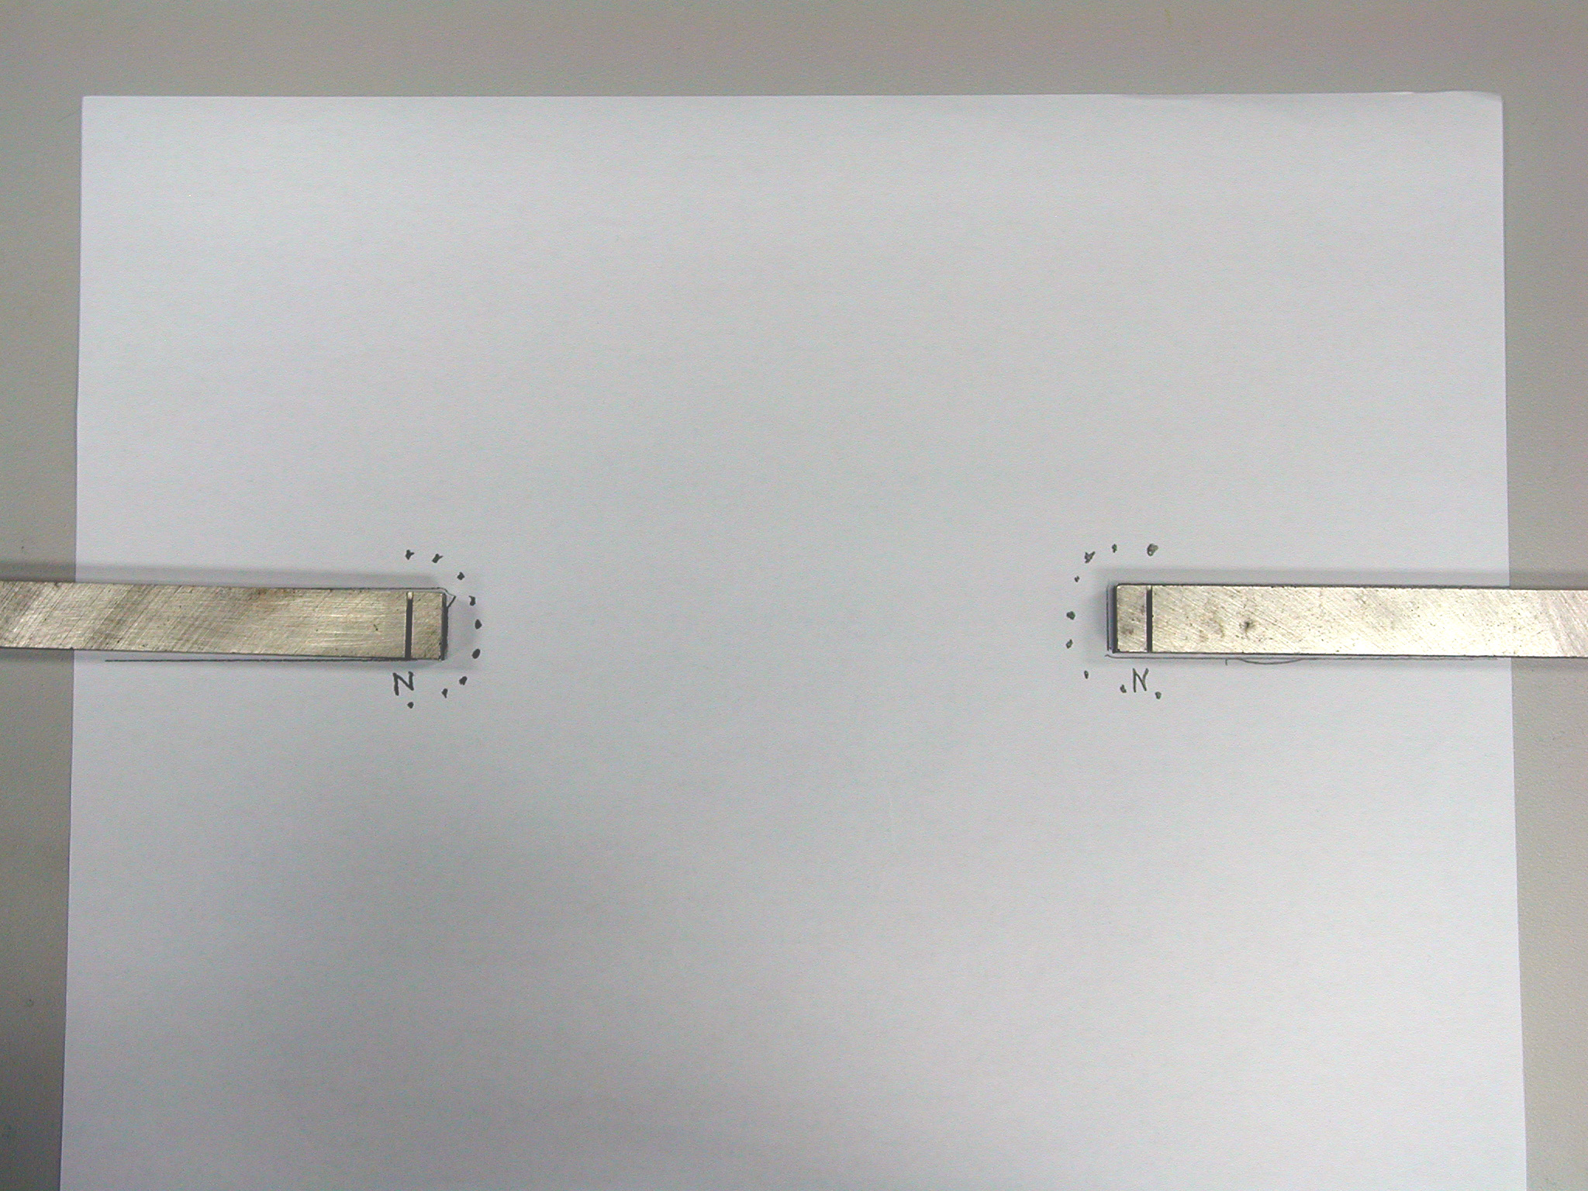 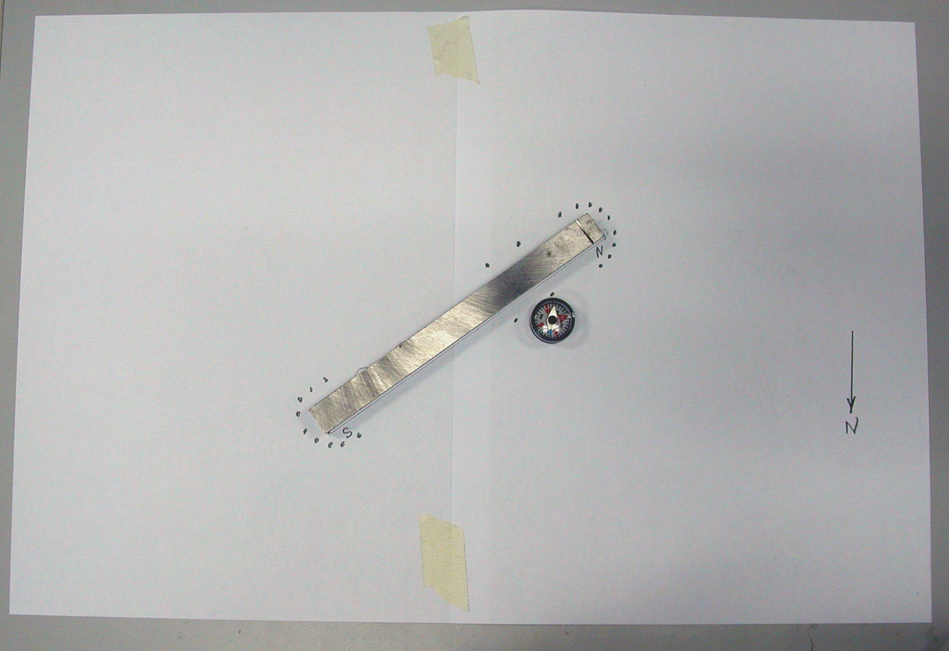

Figure 3: Repulsive Dipole Figure 4: Quadrupole

**Analysis**

Discuss each of the three patterns briefly. Consider the six points discussed in the Theory section. Where is the field relatively strong? Are there any symmetries? Are there any zeroes? Do the lines cross? Do any lines start or stop in space?